# 1.INTRODUCTION

The project aim is to provide real time knowledge for all the students who have basic knowledge of salesforce and looking for real time project .this project will also help to those professionals who are in cross technology and wanted to switch to salesforce with the help of this project they will gain knowledge and can include into their resume as well.

# Problem Definition & Design Think:

* 1. Empathy Map

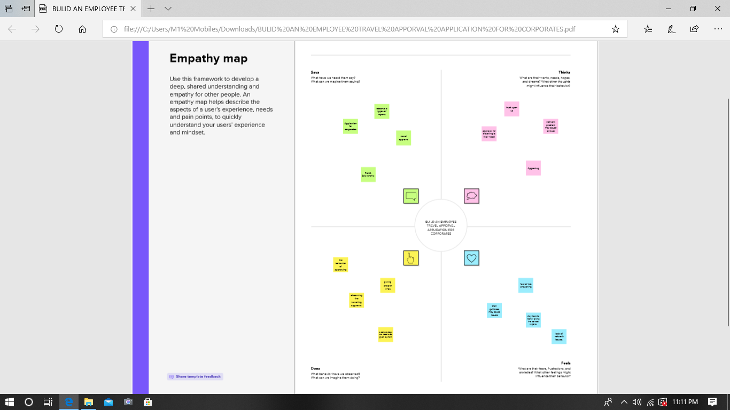

* 1. Ideation & Brainstorming Map

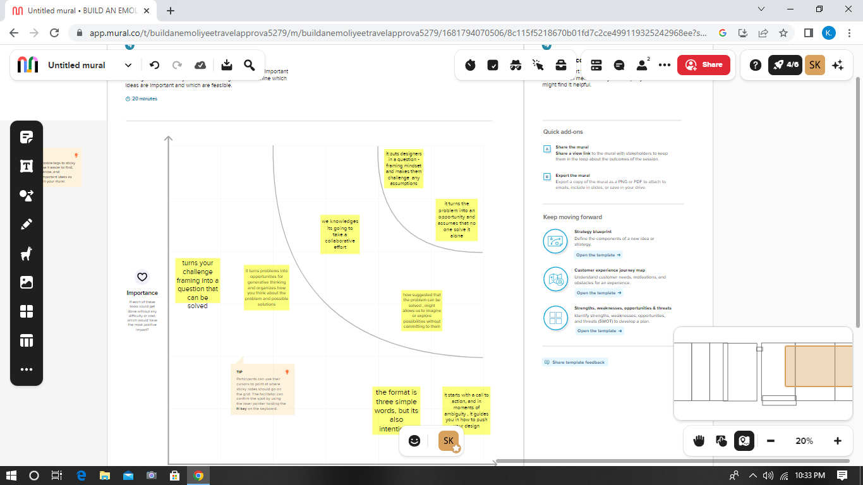

# 2.RESULT:

* 1. Data Model:

|  |  |
| --- | --- |
| Field label | Data type |
| Travel application | text |
| Travel approval | Auto number |

|  |  |
| --- | --- |
| **Object name** | **Fields in the Object** |
| Standard object |  |
| Custom object |  |

# Activity & Screenshot

|  |  |
| --- | --- |
| Field label | Data type |
| 8000 | currency |
| Expense | Picklist |

Attach the screenshots of your project activity along with the description.

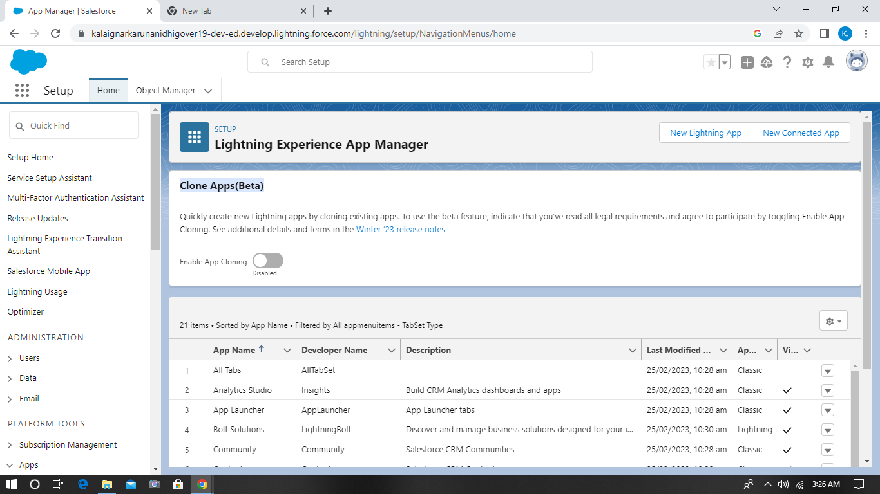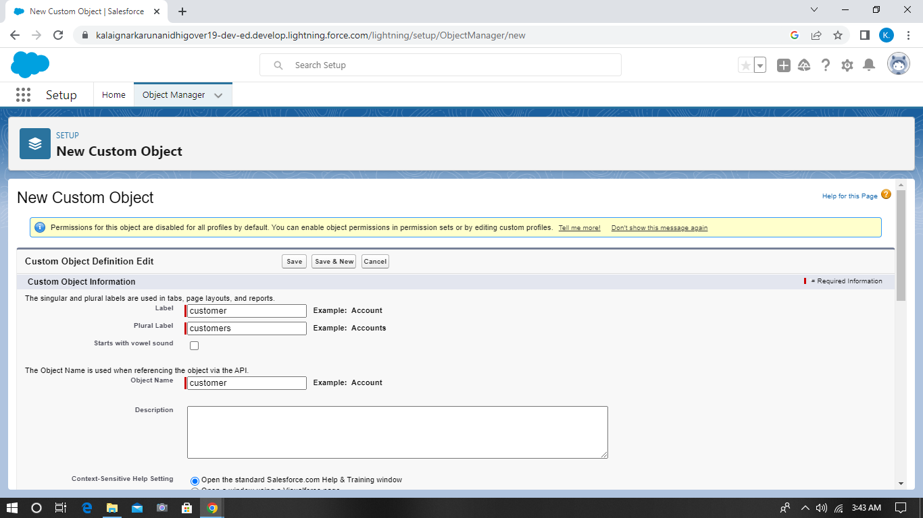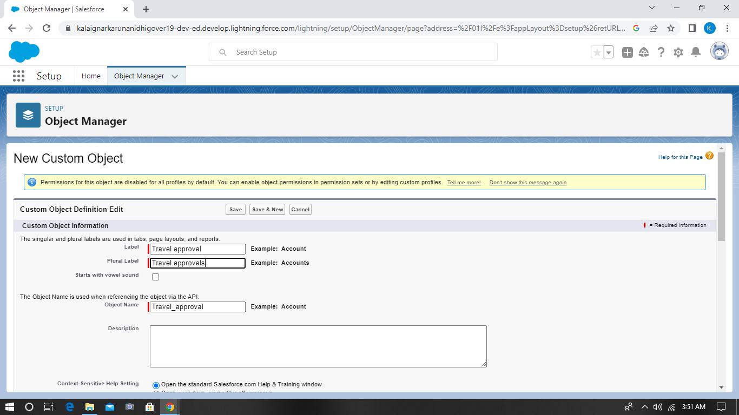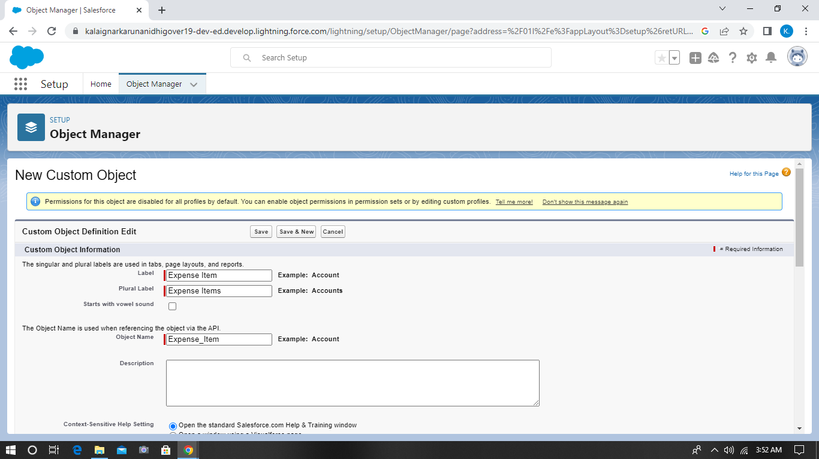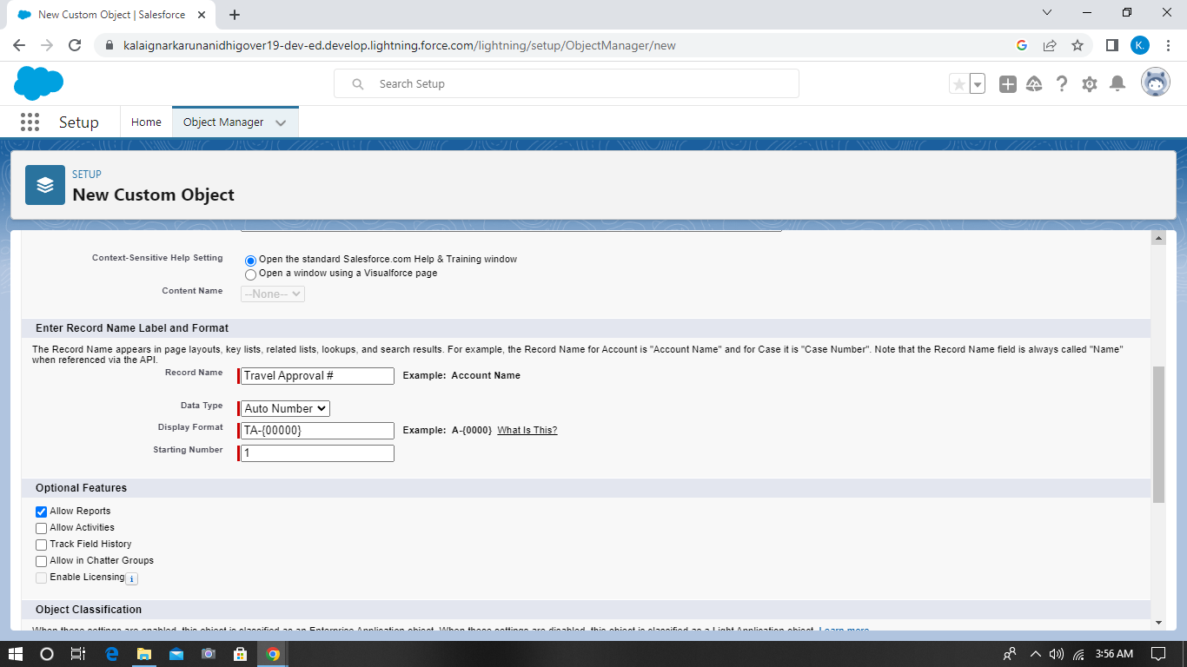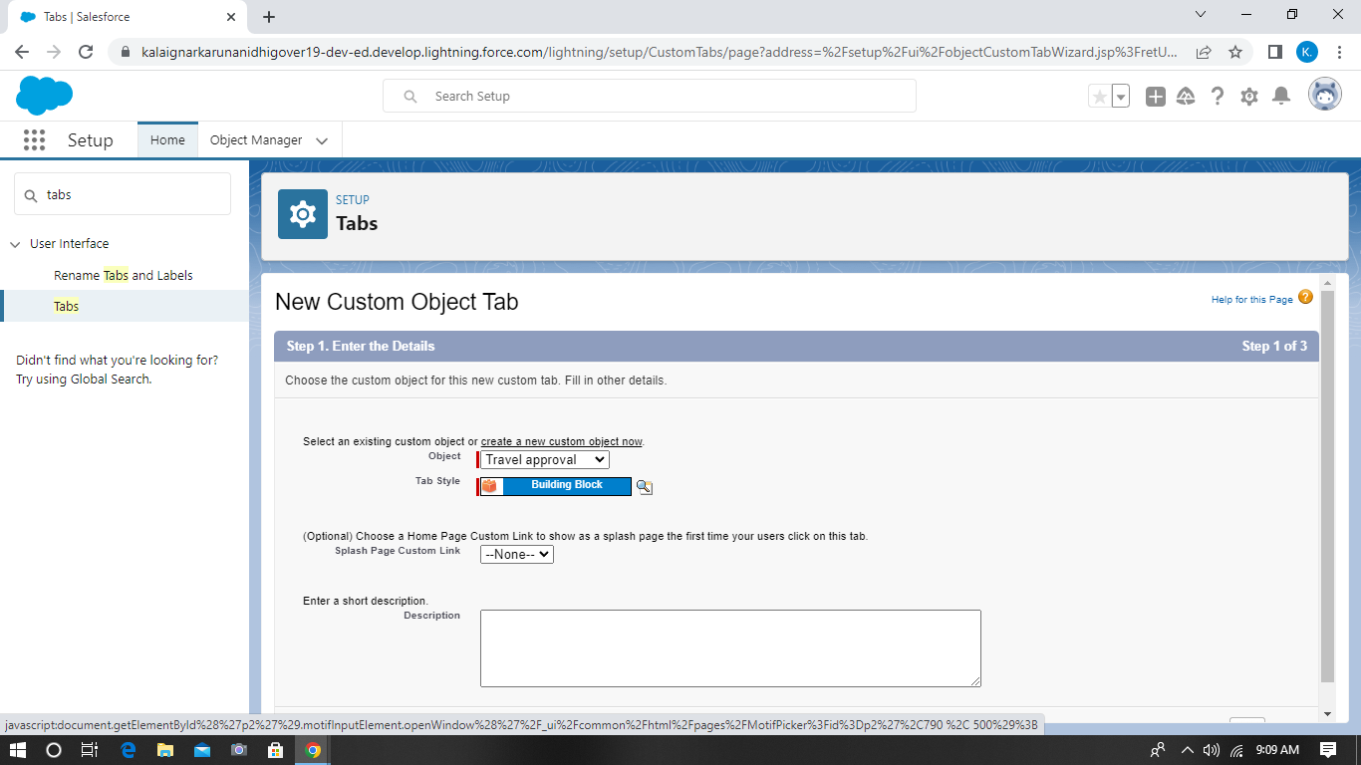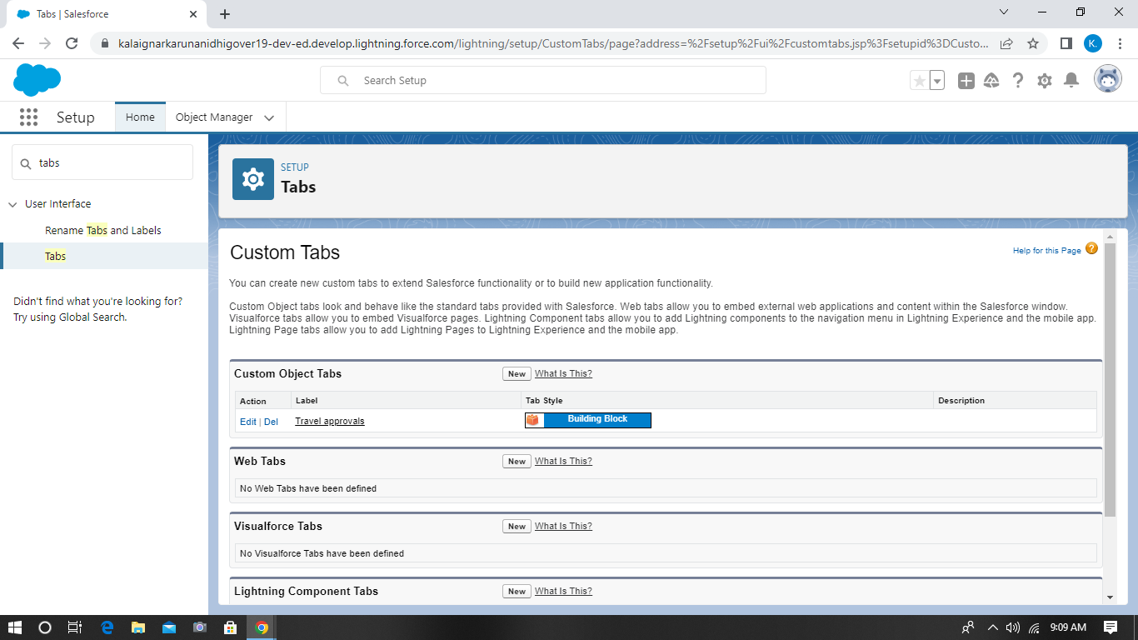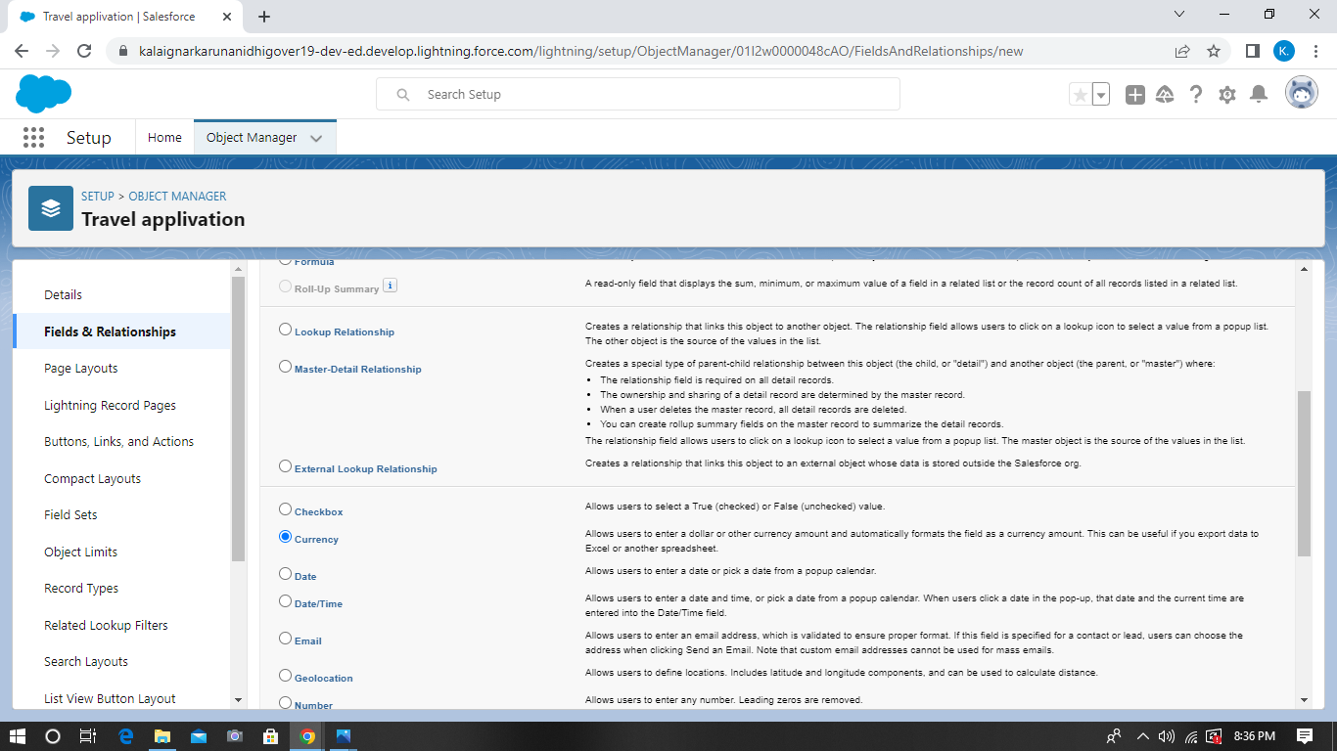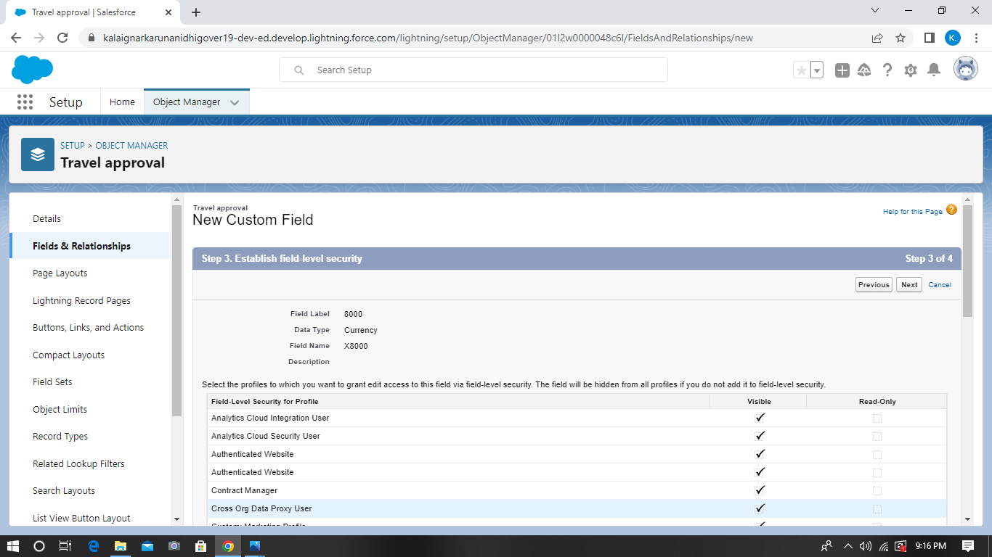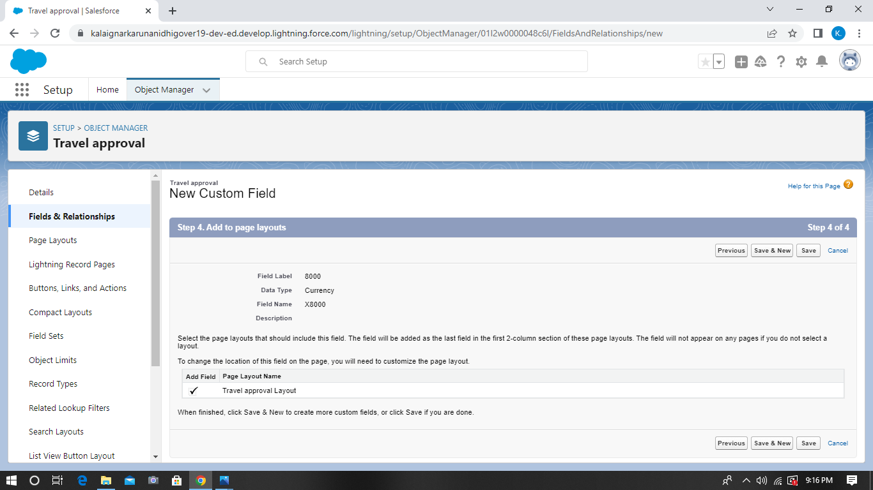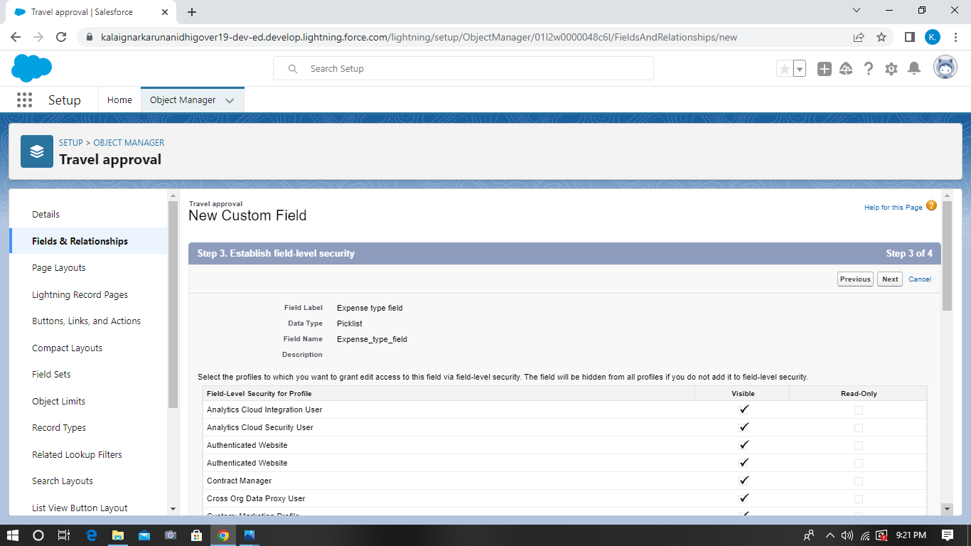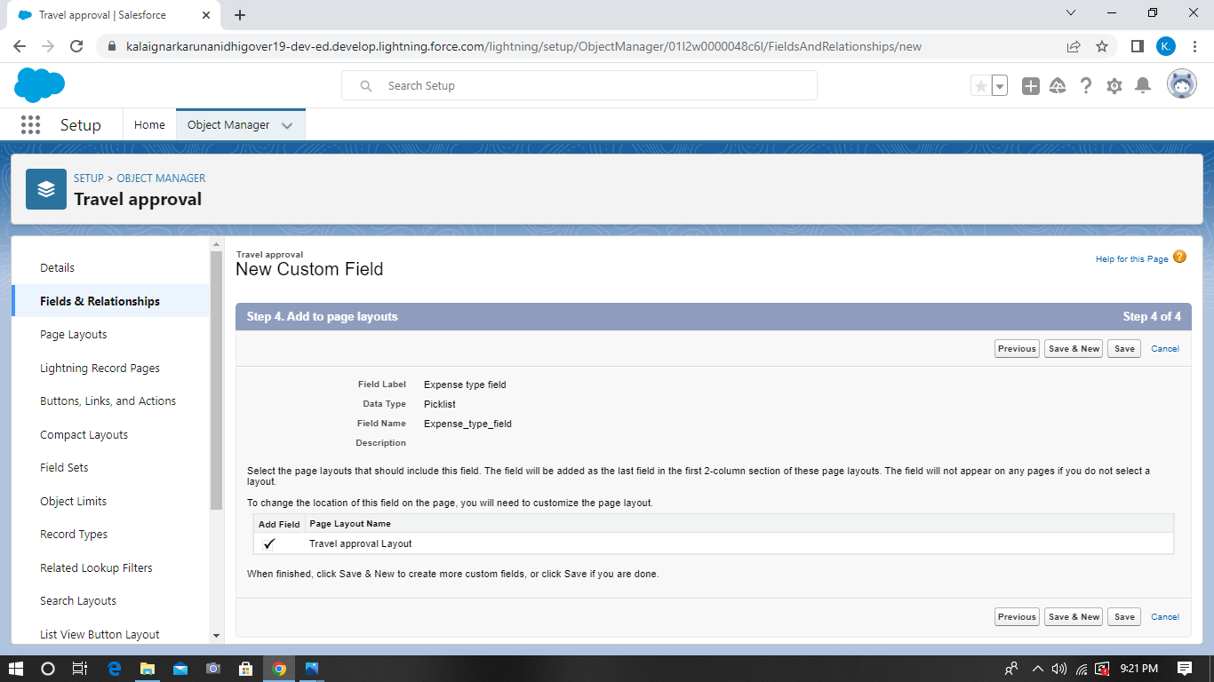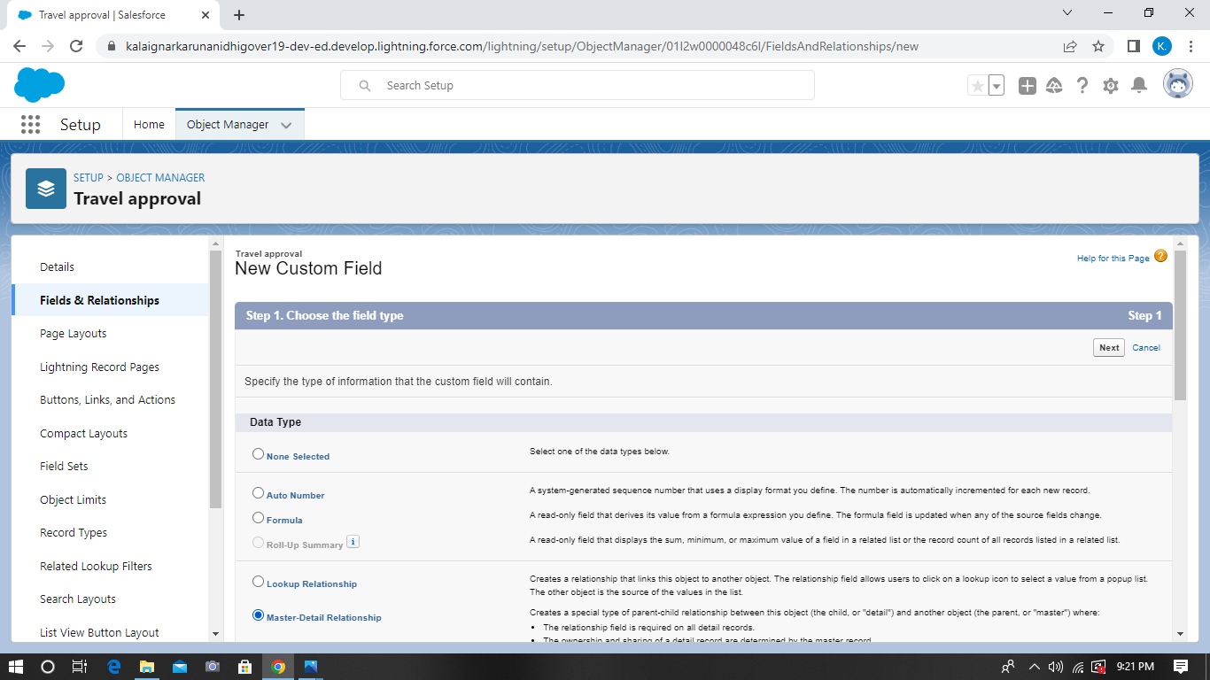

# C:\Users\M1 Mobiles\Pictures\Screenshots\Screenshot (40).pngC:\Users\M1 Mobiles\Pictures\Screenshots\Screenshot (41).pngC:\Users\M1 Mobiles\Pictures\Screenshots\Screenshot (44).pngC:\Users\M1 Mobiles\Pictures\Screenshots\Screenshot (48).pngC:\Users\M1 Mobiles\Pictures\Screenshots\Screenshot (50).pngC:\Users\M1 Mobiles\Pictures\Screenshots\Screenshot (51).pngC:\Users\M1 Mobiles\Pictures\Screenshots\Screenshot (53).pngC:\Users\M1 Mobiles\Pictures\Screenshots\Screenshot (55).pngC:\Users\M1 Mobiles\Pictures\Screenshots\Screenshot (59).pngC:\Users\M1 Mobiles\Pictures\Screenshots\Screenshot (60).pngC:\Users\M1 Mobiles\Pictures\Screenshots\Screenshot (61).pngC:\Users\M1 Mobiles\Pictures\Screenshots\Screenshot (63).pngC:\Users\M1 Mobiles\Pictures\Screenshots\Screenshot (64).pngC:\Users\M1 Mobiles\Pictures\Screenshots\Screenshot (65).pngC:\Users\M1 Mobiles\Pictures\Screenshots\Screenshot (68).pngC:\Users\M1 Mobiles\Pictures\Screenshots\Screenshot (69).pngC:\Users\M1 Mobiles\Pictures\Screenshots\Screenshot (70).pngC:\Users\M1 Mobiles\Pictures\Screenshots\Screenshot (71).pngC:\Users\M1 Mobiles\Pictures\Screenshots\Screenshot (72).pngC:\Users\M1 Mobiles\Pictures\Screenshots\Screenshot (73).pngC:\Users\M1 Mobiles\Pictures\Screenshots\Screenshot (74).pngC:\Users\M1 Mobiles\Pictures\Screenshots\Screenshot (75).pngC:\Users\M1 Mobiles\Pictures\Screenshots\Screenshot (76).pngC:\Users\M1 Mobiles\Pictures\Screenshots\Screenshot (77).png

# 3 Trailhead Profile Public URL

**Team Lead - https://trailblazer.me/id/ksusithra Team Member 1 -http://trailhead.me/id/gsumithra**

# Team Member 2 – https://trailhead.me/id/spriya583

# Team member3 –https://trailhead.me/id/saravanan44

# 

1. **ADVANTAGES :**

**1.Meeting new people** : When you travel you can make new friends and business contacts and even fall in love.

**2.Learning new languages** : What better way to brush up on your language skills than by travelling to a country where that language is spoken.

**3.trying new languages** : New foods ,new sports , you name it.

4.**Challanging your worldview** : Learn to see the world from other peoples perspectives.

**5.Helping others** : Volunteering in another country is very rewarding.

# DISADVANTAGES:

**1.The cost** : Travelling can break the bank balance.

**2.ecological impact** : Flying has a big carbon footprint .

**3.Language barriers** : Travelling can be hard when you don’t speak the language.

**4.Time spent waiting around** : No one enjoys queuing in airports.

**5. Hotel culture**: some hotels are great others are horrific.

# APPLICATIONS:

This tutorial explains how to use the travel approval sample application .

The travel support system is a small sample application for natural ONE. As a sample application, its focus is to show Natural ONE functionality rather than being a full- fledged travel support application.

# CONCLUSION:

Travelling is a wonderful. but there to automate the system. Which is an excellent way to increase your new systems efficiency and speed tremendously.

In conclusion, you should be ready to create your travel request approval workflow to improve compliance, control costs , increase efficiency &accuracy , streamline communication , and enhance security . If you need clarification on how to do this , don’t worry.

You can consult a professional service that can do it for you at a fraction of what you would have to spend to implement one in house.

# FUTURE SCOPE:

As per various studies , the industry is expected to create over 45 million jobs in India by 2025. Students have endless career opportunities in this fast growing industry of travel.